Nutana Community Association (NCA) Gardens
2018 Gardeners Agreement for the Remai Garden
No Potatoes 2018
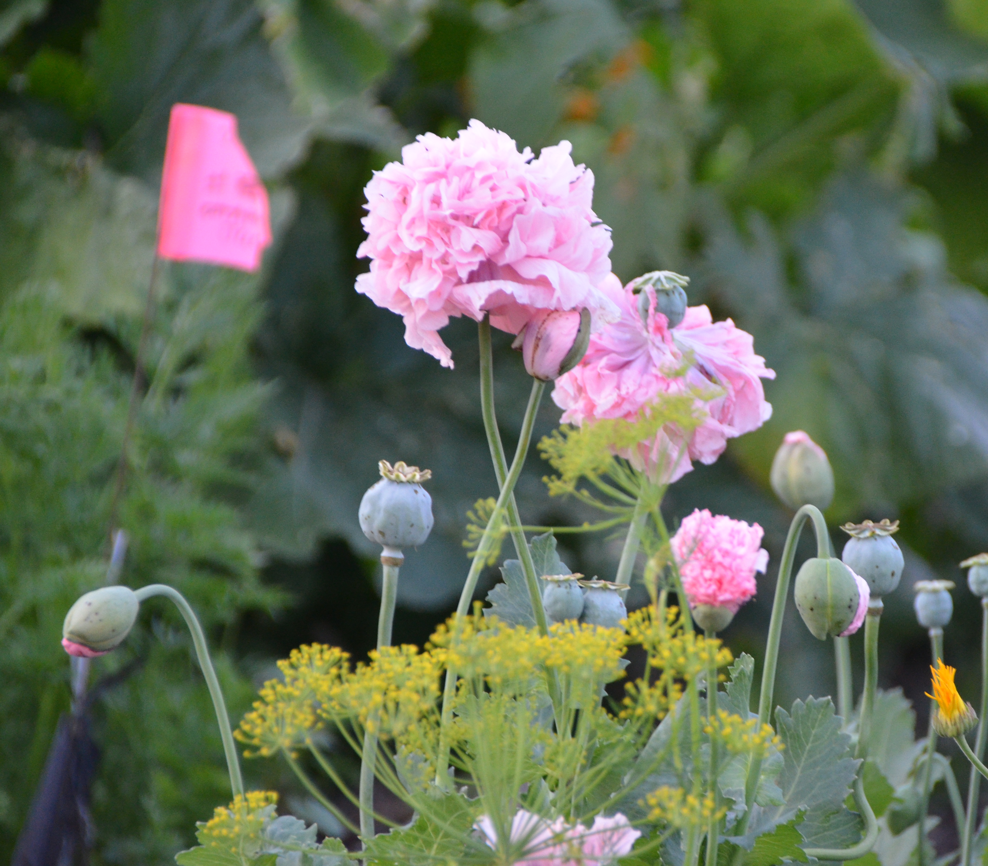
Mission
The Nutana Community Gardens through the sustainable production of food aim to improve health through physical activity, community involvement and growth of nutritious food. The gardens provide a space for learning and development for all ages and cultures and beautify the urban landscape. Cultivation of food and flowers will be undertaken in an environmentally responsible manner. Respect for gardeners, gardens, and the environment is fostered in a supportive community.
Garden coordinator – Margot Hawke
Contact: remai.garden@nutana.ca

Remai Garden – Located on 12th Street east of the Bridgewater Condominiums and west of the Broadway Roastery

Site features –

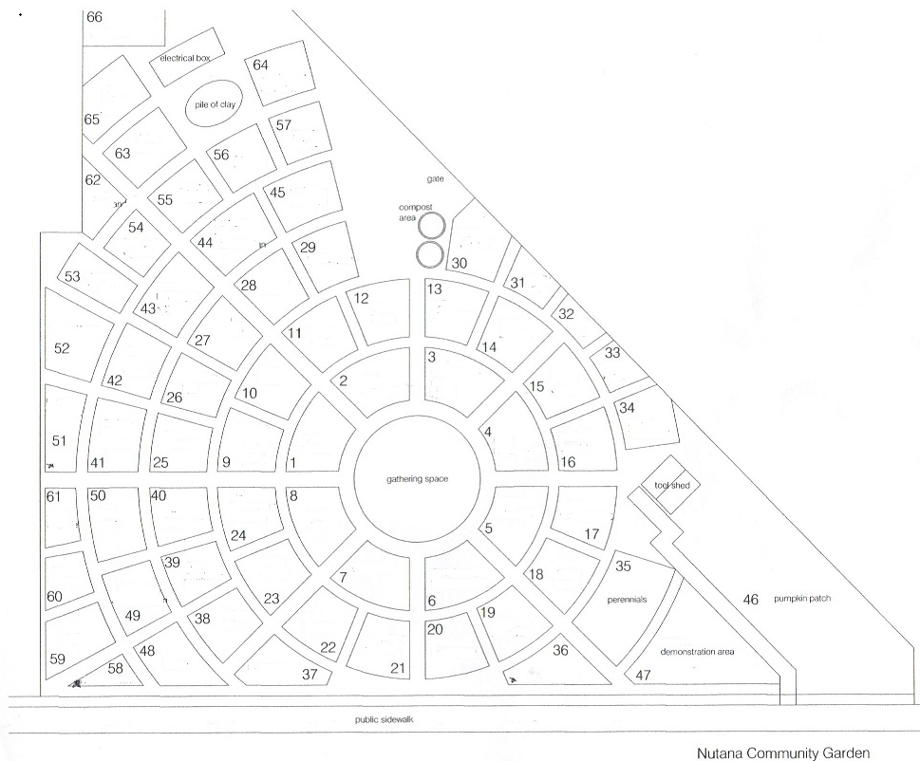
- Individual plots for annual
rental
- Garden shed with shared
tools
- Water Container on site
- City compost pick up
- Wood mulch pathways
- Common raspberry patch
- Herb/perennial/pollinator
garden

Membership Responsibilities

- Register as a Member of the Garden: Membership ($25.00) includes: Rental of a garden plot, access to tool shed, access to water and compost facilities; members are responsible for keeping their plot and surrounding paths weed free, and tool shed tidy. To meet conditions of the garden's land lease arrangement, members must also contribute to general garden maintenance – approx. 4 hours per member. For those who are not already members of NCA, annual membership is $10.
- Sign up for work teams or work bees: Sweet peas, Raspberry patch, Water supply, Wood chips, Shed maintenance, Weeding common areas, ... see page 5
- Planting Date: All plots are to be planted by the first Saturday of June. Plots not planted by this date will be reassigned by the garden coordinator.
NOTE: NO POTATOES to be planted in 2018. We are dealing with Potato beetles.
- Plot Weeding: Garden plot and all pathways are to be kept free of weeds. Weeds with seeds are to be bagged and put into garbage stream - the garden does not maintain a public garbage bin - bag garbage and take it home. Weeds without seeds can be put in to one of the city compost containers.
- Absences: If you will be away during the summer we ask that you invite a friend to care for your plot and/or harvest ripened produce.
- Get to know your neighbour - you can be a great help to each other.
- Inability to Garden: If you are no longer able to maintain your plot, contact the garden coordinator to discuss the future plans for the plot.
- Abandoned plots will be reassigned
A weedy, or unkempt plot will be identified as abandoned. Attempts to contact the owner of the plot will be made; if improvements or arrangements are not made within an acceptable time the plot will be reassigned.
- Plot maintenance and appearance
- Appearance– Please keep your garden plot aesthetically pleasing.
- Garden boundaries must not be changed
- Raised beds may not be higher than 6 inches.
- Weeds must be removed before they go to seed. Each gardener is responsible for removing weeds from their own plot and bordering paths.
- Pests and disease – It is your responsibility to remove pests and diseased plants as soon as possible. Early removal can minimize spread throughout your plot and the whole garden. Although we are not planting potatoes in 2018, check your tomatoes, eggplants & peppers for potato beetles, as they are also hosts – manually remove beetles, larvae or eggs. Please notify the garden coordinator if you find potato beetles in the garden.
SAFETY ISSUE: Do not use any synthetic pesticide (insecticide, fungicide, herbicides, etc.). The garden is much like a public park - pesticides may put people & pets at risk and cannot be applied to the land without permission.
- Compost – Compostable material (e.g. weeds – without seeds) can be placed in the black City of Saskatoon compost bins – these are emptied throughout the summer.
- Planting Practice: Respect for fellow gardeners and the wider community is extremely important in any community garden. Tall plants should only be planted in the center of your plot minimizing shade to your neighbour's plot. Harvest only from your own plot. If you are unable to harvest your produce, arrange for someone else to do the harvest.
- Water: Water is sourced from the fire department, coordinated by a garden volunteer. Mulch plots and use best watering practices. Be considerate of the other 50+ gardeners with whom you share the garden. Be gentle with the valves and equipment - they cannot be quickly replaced. Any water issues report to the garden coordinator.
- Produce Type: The community garden has produced very good root crops such as carrots, and beets. It has also produced very good squash, zucchini, tomatoes, lettuce, beans, peas, and onions. No potatoes are to be planted in 2018.
- Winter preparation: Plots must be fully cleaned out before it snows on the last Saturday of October. Exceptions are winter plantings and perennials.
- Garden Policies: The NCA Gardens are committed to organic gardening practices.
a. Compost from the City is provided most years to augment the soil. Move
compost from the pile to your plot as desired.
b. You are welcome to augment your soil with your vermicompost, manures or other organic sources - or apply synthetic fertilizers at your discretion.

Summary

The well-being of the garden is our shared responsibility. If you notice that something is not as it should be please respond accordingly, either correct the problem (minor issues such as litter or weeds in communal areas) or email remai.garden@nutana.ca

Work bee dates will be scheduled as needed - your time & skills are appreciated

Important dates:
Sunday, April 1 deadline for returning 2017 gardeners to register
Saturday April 21 at 10 a.m. registration for new gardeners in the Remai Garden
Saturday June 2 deadline for planting your plot
Sunday June 3 reassignment of unplanted plots
Sunday October 14 final garden closing day- weather dependent

Assignment of garden plots for 2018
Plots will be allocated by the garden coordinator - every attempt will be made to assign the same plot to returning gardeners, but assignments may not be the same as they were in 2017. A small flag posted in the plot will indicate completed registration and assigned plot.

Welcome to the Garden!
If you have specific needs or problems that might keep you from meeting the conditions of this agreement, please contact the garden coordinator prior to registering.

The Nutana Community Gardens can serve as a powerful model for gardening in our neighbourhood. We look forward to a great season of growth, learning, and community!

Margot Hawke, 2018 Garden Coordinator, remai.garden@nutana.ca

Garden Membership $25 per plot.
NCA Membership $10 (if you are not already a member)
Remai Garden Registration
Returning gardeners will be contacted by email to reregister in March
New gardeners register in the garden on April 21st at 10 a.m.

Cheque(s) – make out to Nutana Community Association

2018 Gardener Registration for the Remai Garden

Name __________________________________________________

E-mail __________________________________________________

Phone __________________________________________________

2017 plot number ____________________________

$25 Payment option-Circle one: Cheque Cash

Choice of work group: Rank in order of preference (1 most preferred). Select 3.*

Sweet Peas
Water
Raspberries
Herb garden
Wood chips
Shed & Tool maintenance and inventory
Pollination garden
Compost
Weeding common areas
Weeding/litter outside fence on 12th
Special projects
Your suggestion:

*Your registration is not complete without your rank ordering for work groups

