An Invitation from your Neighbour

Grace-Westminster Church

505 – 10th Street East

We welcome you to our Adventivity Celebrations Saturday, December 2, 2 until 6 pm (Rides until 3:45)!

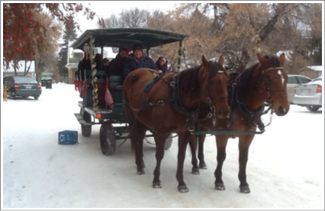
Come for Hot Chocolate, Crafts, Cookie Baking, Carolling, Tree Decorating,

Pot Luck Supper, and Horse Drawn Rides

There is no charge but we are collecting for the Food Bank and gathering new socks to give to those in need if you wish to join in those efforts. Otherwise just come and enjoy the day, for any part of the day. If you want to go on a sleigh ride, you can reserve a time by phoning 306-653-1766 or just drop by.

